A] Implementation of views :

1. Creating a view

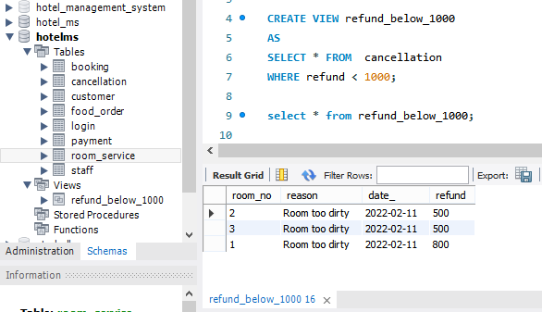

1. Modifing a view

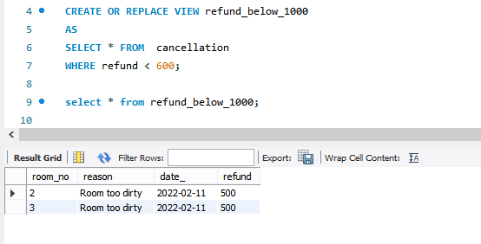

1. Dropping a view

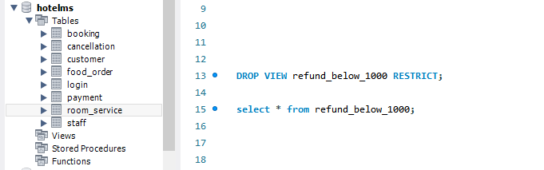

B] Implementation of triggers :

1. Create trigger

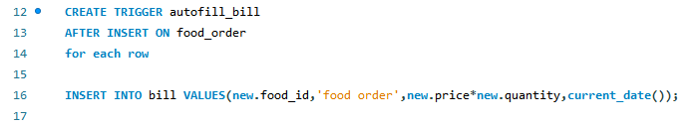

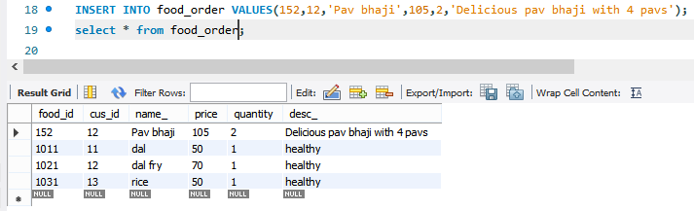

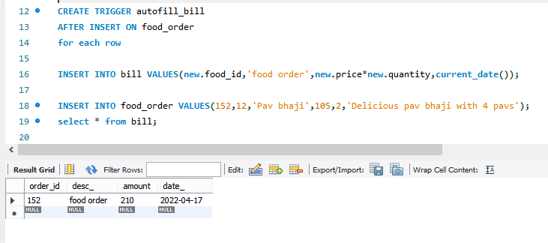

1. Data dictionary for triggers

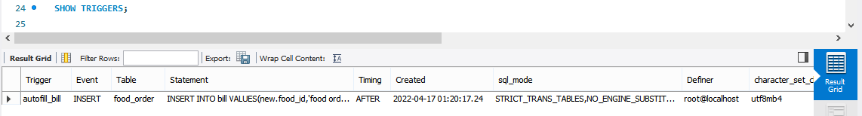

1. Dropping triggers

